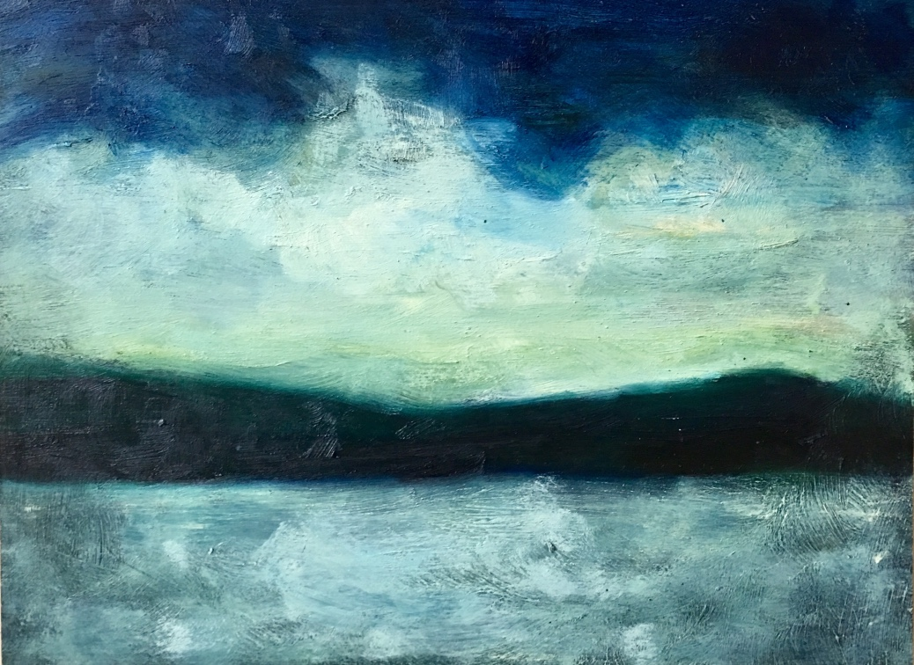

CAYUGA ARTS COLLECTIVE
Sponsored by the Trumansburg Conservatory of Fine Arts

WELCOME
Welcome to CayAC! Our mission is to build a community that fosters creativity in the
visual arts. As a charter member, we invite you to share your ideas for future programs as we strive to further our goals and meet your needs.

Please check any and all interests:
_____ Art Classes - season(s): ____fall ____winter ____spring ____summer
_____ Curating
_____ Exhibiting your work
_____ Teaching/Lecturing - area(s) of expertise? ______________________________
_____ Volunteering

Please check if you are interested in being part of any of these developing programs:
——- Figure Drawing _____ Urban sketch
____ Plein air Painting _____ Watercolor journaling
_____ Printmaking
_____ Museum Trips

Please add your suggestions and comments here: _____________________________
______________________________________________________________________
______________________________________________________________________
______________________________________________________________________

MEMBERSHIP FORM Annual dues waive submission fee to TCFA’s annual spring show & grant 10% off all art classes. Please Note: We will have pedestals in place for the exhibition of 3-d work.

NAME_____________________________________________________________________________

ADDRESS__________________________________________________________________________

PHONE # _______________________________ EMAIL_____________________________________

WEBSITE: _______________________________________________

___ Enclosed is my $25 Annual Membership Dues $_____________
___ Enclosed is my $20 Annual Student (HS/College) Member Dues (age 16 & up) $_____________
___ YES! I would like to donate funds for art exhibition upgrades at TCFA $_____________

TOTAL $ _____________

Please write your tax-deductible check payable to ‘TCFA - CayAC’ and mail to: Trumansburg
Conservatory of Fine Arts, Attn: CayAC, PO Box 1053,Trumansburg, New York 14886

